User’s Manual

EEPROM report generator



**User’s manual**

**Table of content**

Page

1 - General information

1.1 – System overview --------------------------------------------- 3

1.2 – Organization of the manual ------------------------------------ 3

2 - System summary

2.1 – System configuration --------------------------------------------- 4

2.2 – User access levels --------------------------------------------- 4

2.3 – Contingencies ------------------------------------------------------ 4

3 – Getting started

3.1 – Installation ------------------------------------------------------ 5

3.2 – System menu ------------------------------------------------------ 7

3.3 – Exit --------------------------------------------------------------- 8

4 – Using the system

4.1 – New Report ------------------------------------------------------ 9

4.2 – Basic Report ------------------------------------------------------ x

4.3 – Based on previous report ------------------------------------ x

4.4 – About the program ------------------------------------ x

4.5 – Help --------------------------------------------------------------- x

5 - Outputs

5.1 – Report ----------------------------------------------------- - x

5.2 – Program Log --------------------------------------------- x

5.3 – Comparison Log --------------------------------------------- x

6.- System errors

6.1 – Installation ----------------------------------------------------- - x

6.2 – Python libraries ------------------------------------------------------ x

6.3 – Program --------------------------------------------------------------- x

**General information**

**1.1 System overview**

“EEPROM generator report” is a tool which allows generate excel report based on a container file provided by Bosch®.

**1.2 Organization of the manual**

The user’s manual consists of six sections: General information, System summary, Getting started, Using the system, Outputs and System errors.

* General information section explains in general terms the system and the purpose for which it is intended.
* System summary section provides a general overview of the system. The summary outlines the uses of the system’s hardware and software requirements, system’s configuration, user access levels and system’s behavior in case of any contingencies.
* Getting started section explains how to install “EEPROM generator report”. The section presents briefly system menu.
* Using the system section provides a detailed description of system functions.
* Outputs section describes in what way information collected by the application are presented and how to access the information.
* System error provides the complete set of errors may occur during the navigation and how to solve them.

**System summary**

**2.1 System configuration**

“EEPROM report generator” operates on personal computer with Python 3 and Window operating system. It has not been compiled or executed in other operating systems like Linux or Macintosh.

The tool needs connection to Internet in order to auto install python libraries but after it, the application can be used immediately without any further configuration.

**2.2 User access level**

Everyone can use the tool, but only Bosch® members are able to exploit their features and understand them.

**2.3 Contingencies**

In the case of error with python libraries, a command list for the prompt command line in Windows has been added to solve any trouble. You can access to this list in page xx section xx.

**Getting started**

**3.1 Installation**

The first view of the file looks like the following picture in Windows 10.

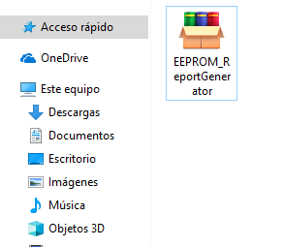

Once the file is put in a desired directory, by opening the file a window appears to extract the python program, just click in “Extract” option and the installer is going to extract the needed files to run the main program.

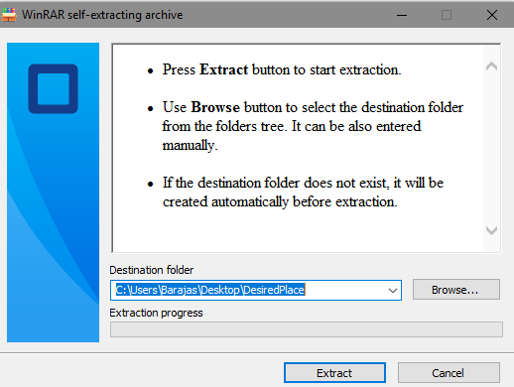

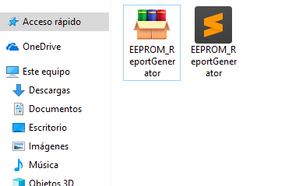

A second file named “EEPROM_ReportGenerator.py” contains the main program. Now, you might delete or move the “EEPROM_ReportGenerator.exe” file to another directory if you want.

The only one thing missing is to install Python 3.x.x which is available for free in https://www.python.org/downloads/. This manual is not intended to explain how to install this program, but the way to know if you have already installed it correctly is by opening your CMD program from Windows 10 and typing the following command.

python --version

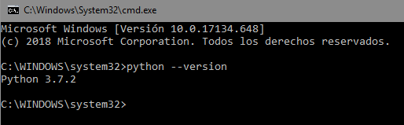

If you reach this point means you are able to run the application and begin to use it. Just by clicking in the file “EEPROM_ReportGenerator.py” the program will install the python libraries needed to make its work. In the case of any kind of error or bad working, the section X of this manual provides information to solve it. The first view of the program looks like this:

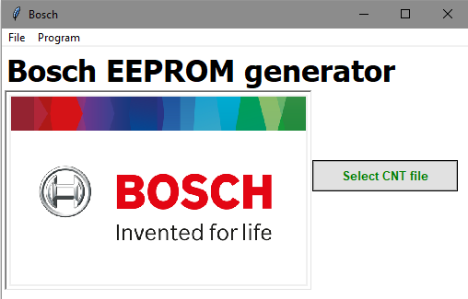

**3.2 System menu**

The application is divided in six basic sections to interact with the final user. The sections are presented in the next picture.

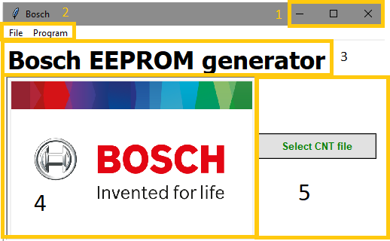

* The first section is used to minimize, expand/collapse and close the program.
* The second section provides the possibility to create new reports, close the program safety, know about the developers and get help.
* The third section provides information about the status of the program every time the user makes an action like select a new CNT file, create the report, select a previous report, etc.
* The fourth section displays the Bosch® logo.
* The fifth section contains the buttons to interact with the program. This section is the core of this tool, so, it is the most important one.

**3.3 Exit**

There are two ways to close the program:

* The first option is by closing the window directly from the section 1 explained before. This action forces to program to close and any information not saved before this action will be lost.

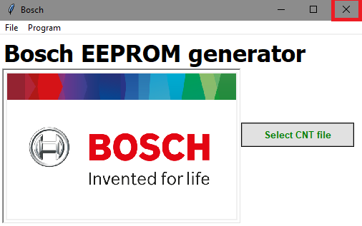

* The second option is through the tool bar options (second section explained before): File $→$ Exit. This option provides the possibility to ask whether you want to close the program over your own risk of losing information.

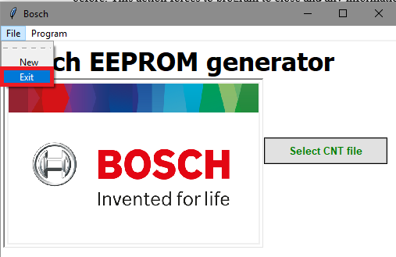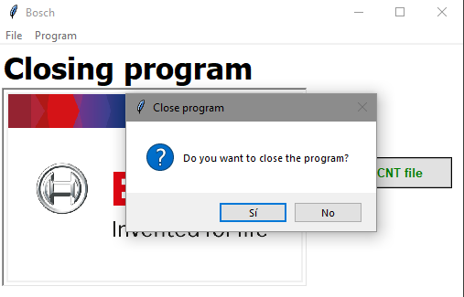

**Using the system**

**4.1 New report**

The first view of the file looks like the following picture in Windows 10.

**4.2 Basic report**

The first view of the file looks like the following picture in Windows 10.

**4.3 Based on previous report**

The first view of the file looks like the following picture in Windows 10.

**4.4 About the program**

The first view of the file looks like the following picture in Windows 10.

**4.5 Help**

The first view of the file looks like the following picture in Windows 10.

**Outputs**

**5.1 Report**

Rubén

**5.2 Program Log**

Rubén

**5.3 Comparison Log**

Rubén

**System errors**

**6.1 Installation**

Rubén

**6.2 Python libraries**

Rubén

**6.3 Program**

Rubén